**SOURCE SHEET**

**Source 1: *Evaluation of Alexander the Great.* Britannica Online: 2023*.* By Frank W Walbank.**

“In the organization of his empire, Alexander had been content in many spheres to improvise and adapt what he found. His financial policy is an exception; though the details cannot be wholly recovered, it is clear that he set up a central organization with collectors perhaps independent of the local satraps. That this proved a failure was partly due to weaknesses in the character of Harpalus, his chief treasurer. But the establishment of a new coinage with a silver standard based on that of Athens in place of the old bimetallic system current both in Macedonia and in Persia helped trade everywhere and, combined with the release of vast amounts of bullion from the Persian treasuries, gave a much-needed fillip to the economy of the whole Mediterranean area.”

*satraps – local ruler of the Persian empire

**Source 2: Tetradrachms (coin) of Alexander the Great.**

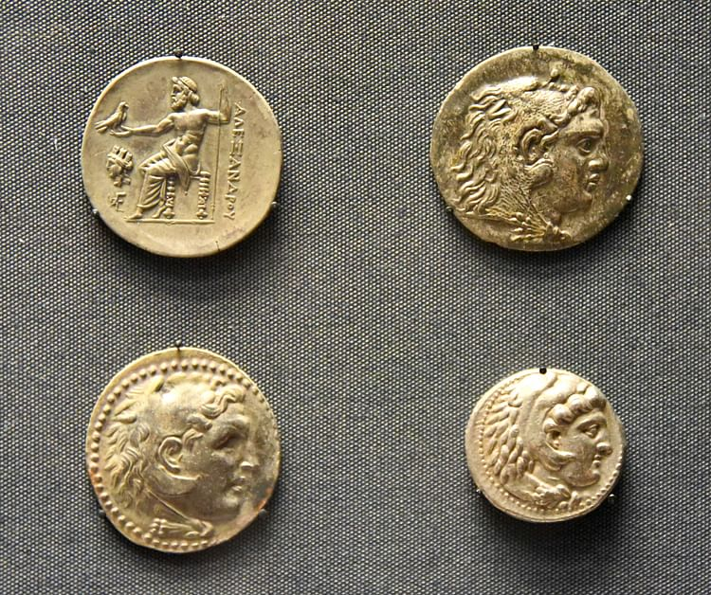

LEFT: From Smyrna, 220-200 BCE (upper left);

RIGHT: Mesembria, 125-65 BCE (upper right)